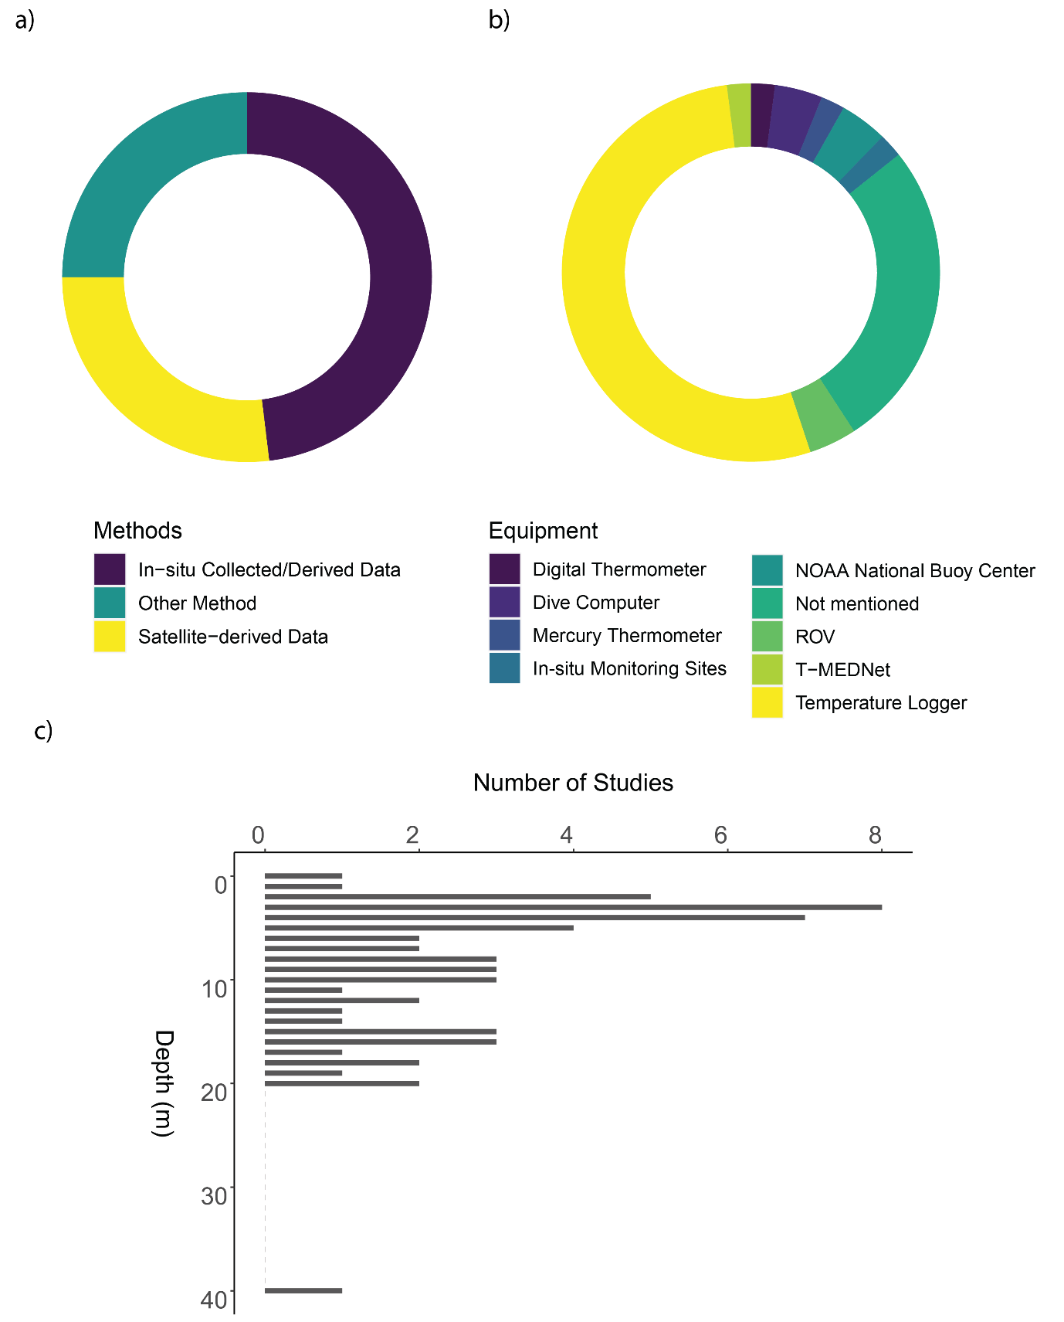

Figure 10 a) Proportion of methods of temperature recording used across the literature included in this study. b) Donut chart showing the proportion of equipment used for studies that recorded temperature in-situ. c) The depth of temperature data collection.